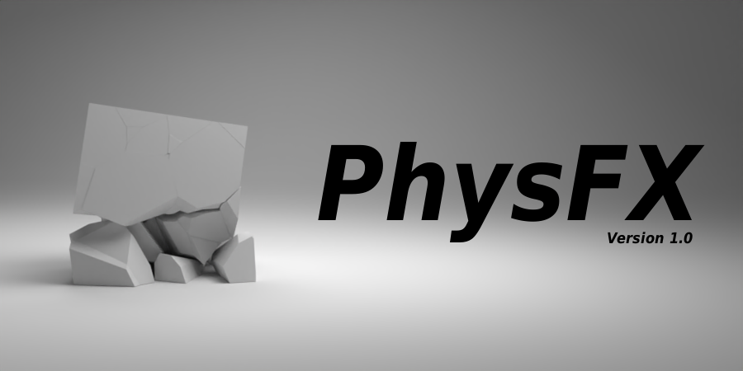
Table of Contents
- Introduction
- Installation
- Tools
- Glue
- Proxymesh
- Group Collisions
- Credits

Introduction

Blender is a free and advanced program that is used by hobbyists as well as professionals. However, compared you other software, its physics tools are not very advanced. Blender has a simple physics system which people have struggled to use properly when creating realistic and accurate simulations.
The idea behind PhysFX is to try and reduce the amount of time spent trying to make realistic physics simulations. With its 3 tools: Glue, Proxymesh, and Group Collisions, PhysFX helps speed up the workflow of aspiring blender artists.
Installation

The best way to install the PhysFX addon is by doing it inside of Blender.

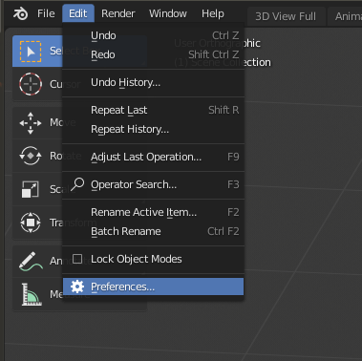
- Open the Blender User Preferences menu and select the Add-ons tab (Edit > User Preferences > Add-ons).

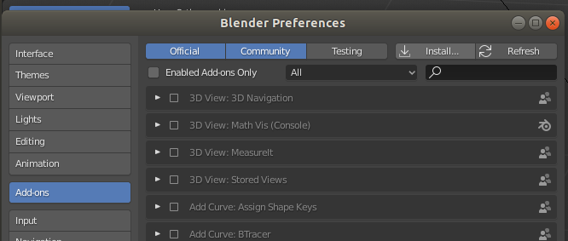
- Click the Install button at the top of the Add-ons menu. This will open a file menu where you can select the PhysFX zip file. (if you already extracted the file, select PhysFX.py).

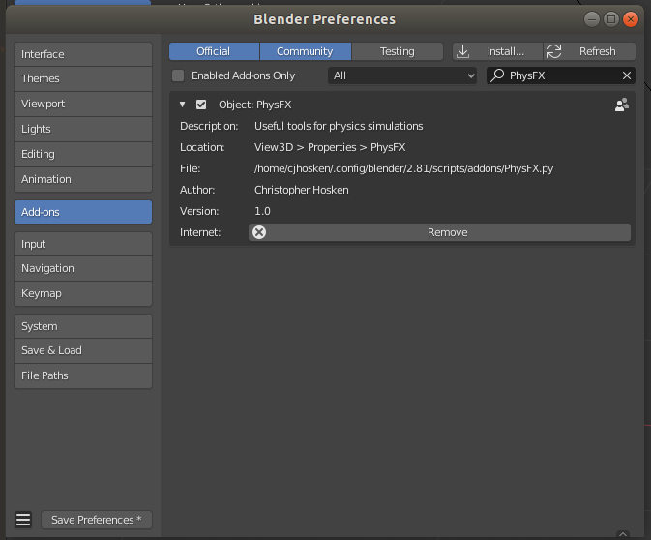
- After installing the add-on file, Blender will filter the addons list to only show the PhysFX addon. Click the checkbox next to the title to enable the addon.

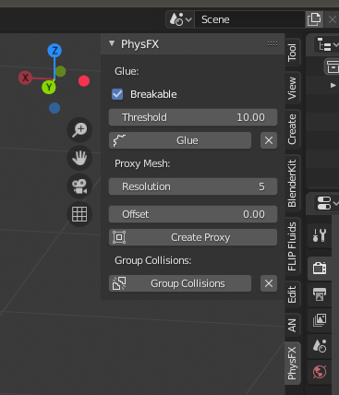
- PhysFX should now be installed into your Blender file. You can find it in the properties panel the right side of the 3D View.

Note: If you have issues with installing and are unable to find an answer online, email blendervvcg@gmail.com for assistance.

Tools

Glue
The Glue tool is used to connect all the objects in a specified collection and makes them break when a certain threshold is met. This lets you create more realistic simulations for the same amount of simulation power.

Example: https://www.youtube.com/watch?v=OGhaJotw5d0&feature=youtu.be

Breakable
Determines whether the glue can be broken or not.
Threshold
specifies the amount of force for the connections between objects to be broken
Glue
Glues rigid bodies together.
Del-Glue
Deletes glue.

Proxymesh
The Proxymesh tool is used to create a boundary mesh that can then be used for soft body simulations. This allows you to speed up simulation times when doing soft body simulations on high poly objects.

Example: https://www.youtube.com/watch?v=iJX_57SN2ms&feature=youtu.be

Resolution
Resolution of the proxy mesh.
Offset
Distance to keep from the target object.
Create Proxy
Creates a proxy mesh around a target object.

Group Collisions

Example: https://www.youtube.com/watch?v=2i11m9dUtHA&feature=youtu.be

Group Collisions
adds the collision property to selected objects.

Del-Collisions
deletes the collision property from selected objects.
Credits
PhysFX was written and designed by Christopher Hosken. If you would like to contact
him, use the info below.

Email: blendervcg@gmail.com

Instagram: https://www.instagram.com/visual_cg/

Artstation: https://www.artstation.com/visualcg

Discord: Cjhosken#7147

